CS 255 System Design Document Template

This template lays out all the different sections that you need to complete for Project Two. Each section has guidance to prompt your thinking. You will need to continually reference the interview transcript as you work to make sure that you are addressing your client’s needs. There is no required length for the final document. Instead the goal is to complete each section based on what your client’s needs are. Remove this note when you are finished, and replace all bracketed text with the relevant information.

UML Diagrams

UML Use Case Diagram

UML Activity Diagrams

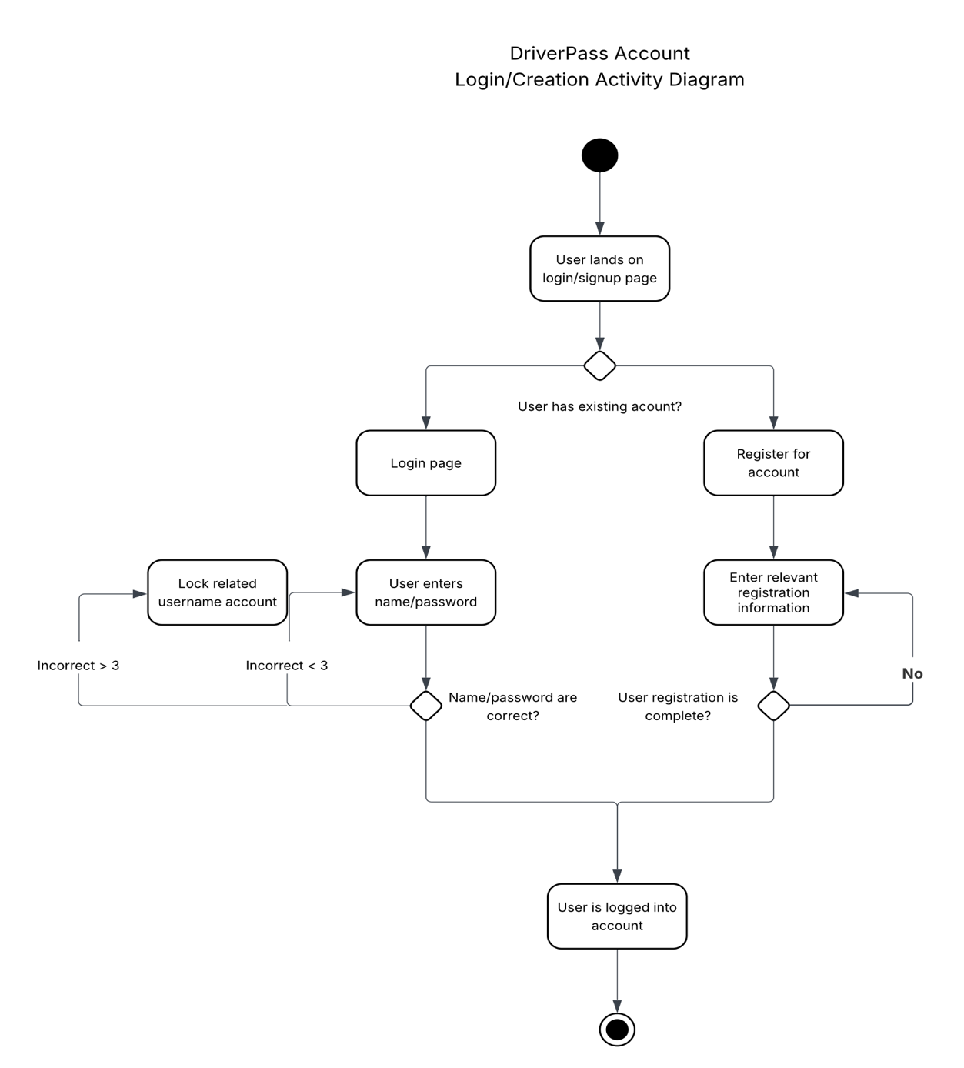

UML Sequence Diagram

UML Class Diagram

Technical Requirements

The DriverPass system will require the following hardware, software, tools, and infrastructure to support its design and ensure reliability:

- Hardware: The system will need a secure web server with sufficient processing power, memory, and storage to support user accounts, practice exam data, driving lesson schedules, and administrative reporting. Client devices accessing the system (desktops, laptops, tablets, smartphones) must have internet connectivity and a modern web browser.

- Software: The server should run a stable operating system (such as Linux) with a web server (such as Apache or Nginx), and a database management system (such as MySQL or PostgreSQL) to manage data. The application may be developed using a web development framework (Node.js, Java Spring, or equivalent) to handle business logic, scheduling, and user authentication securely.

- Tools: Lucidchart was used for designing system diagrams, and additional tools may include an integrated development environment (IDE) for coding, a version control system (like Git), and project management tools to support ongoing maintenance and development.

- Infrastructure: The system will require secure web hosting with HTTPS encryption to protect user data during transmission. It should have automated backup solutions for data recovery and the ability to scale resources to handle increased numbers of users over time.

